|  |
| --- |
| **Projet ANR-N-GREEN**  **Convention ANR-15-CE25-0009-0x** |

**Deliverable D1.1**

**Network and Node Requirements**

Partners of the project

Alcatel-Lucent Bell Labs / NOKIA (ALBLF)

Institut Mines Telecom (Telecom ParisTech, Telecom Bretagne, Telecom SudParis) (IMT)

University of Versailles (DAVID)

III-V Lab (III-V Lab)

|  |  |
| --- | --- |
| Challenge | « Information and Communications Technology (ICT) – 2015 » |
| Project (acronyme) | **N-GREEN** |
| Coordinator of the project | NOKIA/Alcatel-Lucent Bell Labs France |

|  |  |
| --- | --- |
| Partners involved | NOKIA/Alcatel-Lucent Bell Labs France, III-V Lab, IMT, DAVID |
| Reference of the convention/decision | Convention ANR-15-CE25-0009-0x |
| Period of the project  (starting date – ending date) | January 1st, 2016 –December 31st, 2017 (extensible up to September 30th, 2018) |
| Objet | Deliverable D1.1.: Network and Node Requirements |
| Due date | March 31st, 2016 |
| Contributors of the deliverable | Philippe Gravey, Annie Gravey (IMT-TB), Catherine Lepers (IMT-TSP), Tulin Atmaca (IMT-TSP), Djamal Zeghlache (IMT-TSP), Franck Gillet (IMT-TSP), Cédric Ware (IMT-TPT), Dominique Barth (DAVID), Dominique Chiaroni (ALBLF), Brice Leclerc (ALBLF), Bela Berde (ALBLF), Philippe Carré (ALBLF), Joël Leclair (ALBLF). |
| Delivery date | March 31st, 2016 |

# Summary

|  |
| --- |
| This deliverable aims at defining the context of the N-GREEN regarding network and node architectures. After recalling how telecom networks are currently structured, the main evolution trends in terms of traffic volume and nature are presented. These trends include a growth of the global traffic, where video contents play a major role, an increase of the proportion of the traffic issued from mobile terminals (particularly in the context of 5G introduction) and the deployment of small size data centres in regional networks. Another major trend, which concerns the control plane, is the emergence of networks operated “as a service” due to the introduction of SDN and NFV paradigms. Finally, energy efficiency has become a major criteria, in order to limit the CO2 footprint of these future networks.  The introduction of optical switching technologies present a great potential for improving the energy efficiency of the switching nodes of these future networks. The recent evolutions in this field is recalled. In spite of several impressive laboratory demonstrations of optical packet switches, optical switching is only performed at the wavelength channel level, e.g. in ROADMs in present operational networks.  N-GREENs aims at capitalizing on the rather mature technologies (mostly derived from developments realized for next-generation optical access networks). The proposed approach will be based on WDM optical packets that allow taking the best benefit from the wide bandwidth of optical gates and switches which becomes cost-effective thanks to the progresses of optoelectronic integration. These concepts will be applied in the key features of the future nodes, namely a WDM by-pass of a packet node and a WDM backplane of a high capacity (100 Tbit/s) router. The considered use cases include core and metro/core networks and also new fronthaul network architectures. Detailed objectives are summarized at both node and network levels. The requirements will include cost, performance, and energy consumption, together with the functionality and the scalability of the proposed solution. |

Table of Content

Table des matières

Summary 2

List of Acronyms 5

I Introduction 6

II Network and Node Architecture: Context and Main Issues 7

II.1 Usual telecom network architecture and main evolution trends 7

*II.1.1* *Metro networks* 8

*II.1.2* *Fronthaul and backhaul* 8

*II.1.3* *Core networks* 10

II.2 Traffic evolution in terms of volume and distribution 11

II.3 Impact of fixed/mobile structural convergence in the access and aggregation networks 12

II.4 Energy constraints 15

II.5 Current Architecture of Network Nodes 19

II.6 Emergence of new control plane technologies 21

*II.6.1* *Objectives of emerging SDN and NFV paradigms* 21

*II.6.2* *Examples of current SDN control in Optical Networks* 23

*II.6.3* *Objectives for the N-GREEN nodes and networks* 24

II.7 Recent Technological advances 25

*II.7.1* *Advances on devices* 26

*II.7.2* *Advances on switching architectures* 27

*II.7.3* *Example of Optical slot switching architectures: POADM and TWIN* 28

III N-GREEN Targets 32

III.1 Use cases 32

III.2 Investigated solutions 33

III.3 Expected results 36

IV Requirements for the N-GREEN Network Solutions 36

IV.1 General network objectives 36

IV.2 Specific objectives per network segment 38

V Requirements for the N-GREEN Node Solutions 40

V.1 General node objectives 41

V.2 Specific node objectives 41

VI Conclusion 43

References 44

Table of Figures

*Figure 1 : Global view of usual telecom network architecture* 8

*Figure 2 : Schematic view of front-, mid- and back-hauling.* 9

*Figure 3 : Forecasted global fixed and mobile traffic growth (from CISCO-VNI [11])* 11

*Figure 4 : Forecasted growth rates of the different network segments (from CISCO-VNI [11])* 12

*Figure 5: picture of a CWDM fronthaul in Nokia Bell Labs* 14

*Figure 6: Optical technologies for fixed-mobile convergent access networks [41]* 14

*Figure 7 : Repartition of the energy consumption per network segment* 16

*Figure 8 : Diagram showing the different directions to reduce the energy consumption of products.* 18

*Figure 9 : contribution in terms of energy (GW during year 2013) consumption per terminal.* 18

*Figure 10 : Some examples of risks in the case of energy shortage* 19

*Figure 11: General node structure* 20

*Figure 12 : SDN based controlled Infrastructure* 22

*Figure 13. SDN/NFV framework for the control and management of N-GREEN oriented networks* 25

*Figure 14 : CFP2 module for low cost (< 1k€) and low power consuming TRX (< 12W)* 26

*Figure 15: Mel WR32 RSOA-based transceiver* 26

*Figure 16 : a 4x4 switch from Venture Photonics(component, principle and final module), b: 16x16 switch from Tu/e (chip with ribbons)* 27

*Figure 17: layer model showing the possible position of POADM or TWIN technologies* 29

*Figure 18 : POADM node structure* 30

*Figure 19: Illustration of TWIN principle and scheduling* 31

*Figure 20: (a) Global structure of the node, (b) simple implementation scheme* 34

*Figure 21 : description of the structure of the proposed backplane* 35

*Figure 22: Long term vision for the disruptive technology proposed in N-GREEN* 36

*Figure 23 : General figure showing three proposed innovations. Only two of them will be investigated in this project: the dynamic optical bypass and the high capacity backplane.* 40

# List of Acronyms

|  |  |
| --- | --- |
| BBU | BroadBand Unit |
| CN | Concentration Node |
| CO | Central Office (at the border of access and metro/access networks) |
| Core CO | Core Central Office (at the border of metro/core and core networks) |
| CPRI | Common Public Radio Interface |
| EN | Edge Node |
| Main CO | Main Central Office (at the border of metro/access and metro/core networks) |
| MBS | Macro Base Station |
| NFV | Network Function Virtualisation |
| OLT | Optical Line Termination |
| RAN | Radio Access Network |
| ROADM | Reconfigurable Optical Add-and-Drop Multiplexer |
| R-SOA | Reflective Semiconductor Optical Amplifier |
| SDN | Software Defined Network |
| SOA | Semiconductor Optical Amplifier |
| RRU | Remote Radio Unit |
| WDM | Wavelength Division Multiplexer |
| WSADM | WDM Slotted Add/Drop Multiplexer |
| WSS | Wavelength Selective Switch |

# Introduction

Telecommunication networks will face major challenges in the next 5-10 years. The first one is the continuous growth of traffic volume (about 25-30% per year according to several studies). A major reason, which is in line with the evolution observed during the last period, is linked to the steady growth of the video traffic. On the one hand, new formats, requiring higher bit rate per video channel, will be introduced (from SDTV to HDTV and then to UHDTV, etc.) and on the other hand subscribers increase video usage, especially with mobile terminals connected either to the fixed access network using WiFi interfaces or the mobile access network (4G and soon 5G standard). Besides this traffic, dedicated to human users, Machine to Machine (M2M) traffic related to the deployment of the Internet of Things (IoT) is expected also to take off during the next years. As this traffic is generally based on extremely small flows, it should represent still less than 5% of the total traffic in 2019. But this figure could evolve significantly in the 2020 decade. Moreover, most of the data gathered by IoT devices will be stored in data centres and become part of the so-called “Big data”, which are expected to constitute a huge resource for new applications and business models. Of course, the afore mentioned video contents will be also be hosted in data centres, possibly dedicated to content delivery.

The major contribution to be expected from these data centres to the global traffic yields a major shift in telecom network design. Till recently, these networks had to connect traffic sources/destinations with a well-defined position (for both fixed and mobile users). In the future, it becomes preferable if not necessary to jointly optimize the network design and the location of the content located in data centres. In that context, it is quite intuitive that it would be advantageous to distribute data centres within the network infrastructure in order to store popular content close to end-users.

Besides this quantitative and qualitative evolution of the traffic, a second major issue of ICT networks is their energy consumption. In fact, the network doesn’t represent by itself the main cause of ICT energy consumption (which comes from customer equipment and data centres). However, it is clear that the expected traffic growth will be sustainable only if the energy efficiency of the main network equipment is also improved. It has been recognized that optical technologies are more energy efficient than electrical technologies when used to transport information. This advantage also increases when the bit rate and/or the distance increase. The comparison becomes more tricky when considering the implementation of switching functions. Indeed, the nature of electronics makes it much more suited than optics to the integration of the large number of elementary functions that are needed to filter, store and forward high bit rate data flows. In a nutshell, it is quite hard to efficiently store optical packets. However, the tenants of optical switching try to demonstrate that the role of digital switching could still be reduced or even suppressed by using simpler (i.e. needing less bit level processing) approaches. It has indeed already been demonstrated for applications where switching can be performed slowly (at millisecond scale at least) and rarely: ROADM cards are nowadays commonly used in optical transport networks nodes in order to provide a transparent by-pass for the traffic that does not need to be locally switched or regenerated.

However, until now, in spite of a lot of research in that field, fast optical switching technology hasn’t yet been able to play a role in operational systems. The reasons for that are multiple and they have been debated among the technical community. They include in particular the lack of optical memories, and the cost and the difficulty to integrate fast optical switches. The impact of the first issue may be limited, or even cancelled, using specific approaches, such as POADM or TWIN, which allow a end-to-end transparent transport of time slots, without buffering in intermediate nodes. Detailed performance evaluations of these architectures have shown that they are able to provide carrier-grade performance with a suitable dimensioning of network resources. However, both rely on fast (~ 10 ns) tuneable lasers, which are still costly and delicate to operate, (mainly due to their wavelength instability), even in a laboratory environment. The SOA-based optical gates that are used in POADM are more mature, but still suffer from a rather modest integration level, especially when each of them operate on a single wavelength channel.

In that difficult context, the N-GREEN project attempts to propose pragmatic, medium-term solutions for “greener” (in particular, with increased optical transparency) optical networks. To this end, the project will put a particular emphasis on two related issues, namely cost-effectiveness and simplicity of the proposed optical switching technologies. Three network segments will be considered in N-GREEN: metro-access (especially in the context of back-hauling of future 5G traffic), metro-core (taking into account the evolution of traffic sources, such as the emergence of distributed data centres) and core networks (by proposing innovative multi-tera-class-router architectures).

Consistantly with the N-GREEN approach, focus will be put on low-cost solutions derived from the optical access mass-market and on the most efficient use (in bit/s/€ or bit/s/J) of optical technologies. The realism of these solutions will also be a major concern: N-GREEN doesn’t target an “all-optical” router solution but aims at introducing as much as possible optics for by-pass traffic and in equipment backplane.

This deliverable is organized as follows. Section II summarizes the main issues faced by modern telecom networks and nodes, taking into account, in particular, traffic evolutions and energy-consumption requirements. Section III describes the three main targets of the project, namely a solution for metro-access rings, a solution to provide a dynamic optical by-pass in metro/core and core nodes and optical back-plane for core routers. Main objectives and/or preliminary specifications are summarized for all these solutions, in section IV for network-level parameters and in section V for equipment-level characteristics. Finally, section VI concludes the deliverable and gives an insight on the next steps of the work inside WP1.

# Network and Node Architecture: Context and Main Issues

## Usual telecom network architecture and main evolution trends

In general, telecommunication networks are used to connect large groups of users spread over a geographical area. In order to ensure an efficient connectivity, the current operator networks are designed in a hierarchical way depending on the covered area and the traffic aggregation process. A node in a given level aggregates the traffic coming from the immediate lower level, yielding to higher stages of traffic aggregation. As shown in *Figure 1*, three levels of hierarchy: access, metro and core are basically defined.

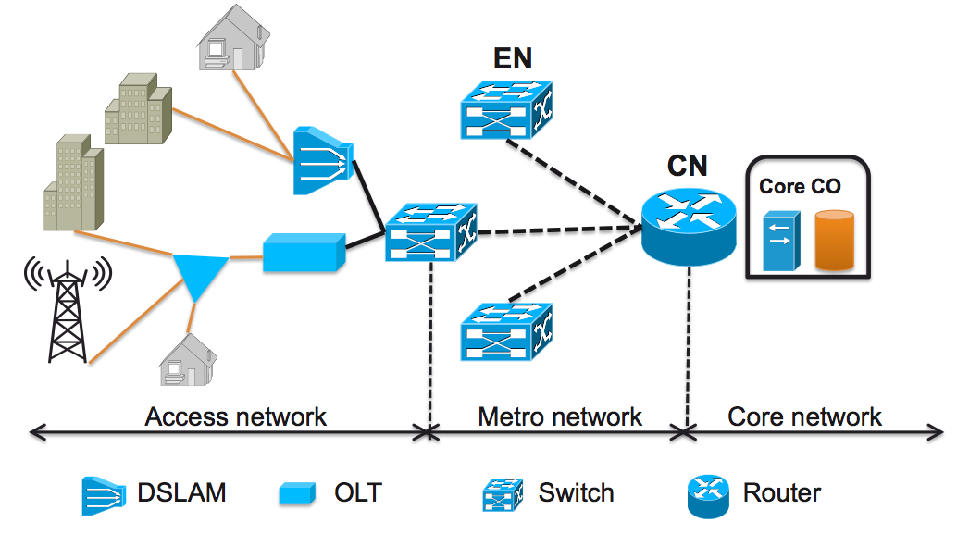

*Figure 1 : Global view of usual telecom network architecture*

## *Metro networks*

In the metropolitan network the nodes can be classified into two types: Edge Nodes (ENs) and Concentration Node (CN) [1] as illustrated in *Figure 1*. ENs aggregate fixed and/or mobile traffic coming from the access network nodes (i.e., OLTs, ... ). ENs are often located in medium sized areas or cities. All the aggregated traffic in the ENs is transmitted to a CN, which is responsible for ensuring the connection between the metro and the core network. The CN is the first aggregation node in the core network. The CN aggregating all the traffic in each metropolitan network is connected to the Core Central Office (Core CO). The above-described architecture requires a huge buffering capacity and a large amount of computing resources in the CN to filter and more generally manage all the traffic flows passing through it.

Metro networks are generally split into two network segments: the metro access / aggregation and the metro core / regional metro. The metro access/ aggregation network is responsible for the first level of aggregation of the traffic generated by the central offices. The metro core / regional metro represents the network segment interconnecting the metro access/ access aggregation networks to the core network.

## *Fronthaul and backhaul links*

Today, radio sites (i.e. Base Stations) are typically connected via dedicated fixed access links or microwave to the fixed aggregation network. From there, the traffic is tunnelled through towards the mobile core within the fixed network infrastructure. This results in a centralised topology where all physical network links are connected up to an access router of the mobile core.

Today, there are two dominant Radio Access Network (RAN) architectural options: backhaul and fronthaul. The legacy architecture relies only on backhaul links, and is called “Distributed RAN” (D-RAN), whereas fronthaul links enable Centralised RAN (C-RAN) [2]. In a C-RAN, the radio coordination is controlled by centralised BaseBand Units (BBUs), located in BBU Hotels (BBUH). In a D-RAN, the coordination can be done with or without a central entity called Radio Coordination Controller (RCC) , . The main difference between Fronthaul and Backhaul links is that the bandwidth requested by the former is significantly higher than the one requested by the latter. On the other hand, BBUs can be more efficiently shared in a C-RAN as the BaseBand functions are not realised within the base stations.

Backhauling and fronthauling are not the only options for the aggregation of mobile traffic. For instance, the “midhaul” scheme assumes that L1 and some L2 functions of the BBU remain located at the base station, while L3 and other L2 functions are virtualized, e.g. in a core CO. This approach allows relaxing the propagation time constraint between the base station and the virtualized BBU. All these schemes are illustrated on *Figure 2*.

The link between the central coordinator (RCC/BBUH) and the coordinated radio cells must fulfil certain requirements, especially in terms of delay, related to Coordinated Multi-Point (CoMP) transmission and reception , [6] shows a broad classification of coordination schemes including their expected gains and delay requirements. Radio coordination time will be required even in 5G mobile network (which is just in the starting phase of description) in co-channel deployments. It is currently expected that these requirements will not be more stringent than the very tight coordination time schemes of Long Term Evolution-Advanced (LTE-A) (0.1 to 0.5 ms, in the fronthaul case).

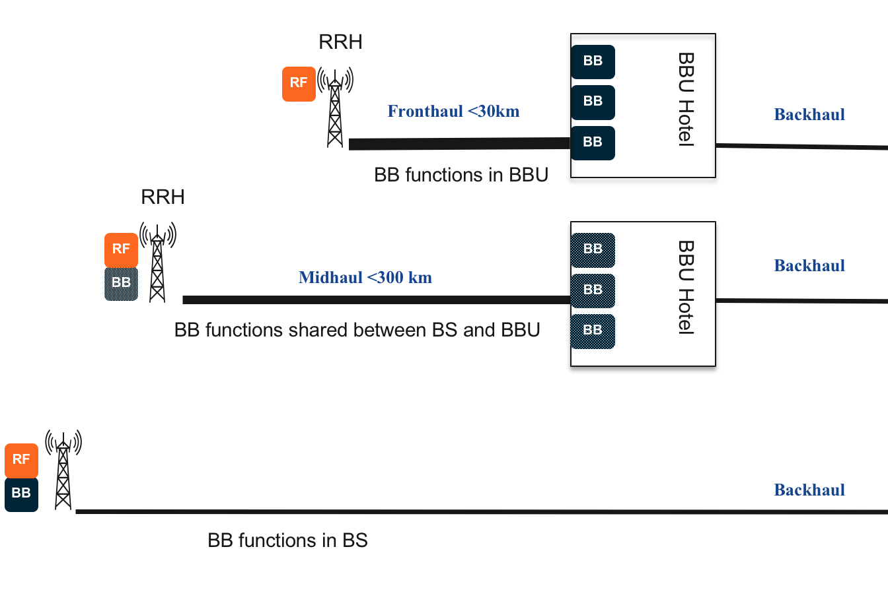

*Figure 2 : Schematic view of front-, mid- and back-hauling.*

One still open key issue from a transport/backhauling perspective is how the new 5G radio nodes will be backhauled. One obvious direction would be by looking at 4G, where we see two dominant ways of connecting the small cell sites: Packet-based backhauling of a full MBS or Common Public Radio Interface (CPRI)-based fronthauling of RRUs. With 5G, the industry is also exploring other options, including splitting higher up in the RAN stack in order to keep the 5G small cells as simple as possible as well as to be able to sustain their requirements for connectivity.

The bottom picture in *Figure 2* shows a high-level overview of the backhaul transport network principal. The macro- and small- cell BBUs are located in their own cell sites and backhauled via Internet Protocol of Ethernet (IPoE) links. The backhaul transport dimensioning in the access network mainly depends on the mobile technology, the radio configuration as well as the applied radio coordination schemes, taking into account data rate, latency and synchronisation requirements. The radio configuration is typically designed for offering a sustainable data rate during the busy hour and a certain peak data rate, driven by technology evolutions. The backhaul link is typically dimensioned according to the peak data rate of cell, e.g., 150 Mbit/s for 20 MHz LTE [7].

The top picture in *Figure 2* shows a high-level overview of the fronthaul transport network principle. The BBUH is located in a central location (e.g., Main CO), leaving only the RRU at the cell site. The distance between the RRU and the BBUH is constrained by the timing requirement of the respective radio technology. For LTE, the Hybrid Automatic Retransmit reQuest (HARQ) protocol is used as a retransmission mechanism between UE and eNB. The standard foresees less than 3 ms for BBU processing. If the BBU is moved away from RRU, the additional delay caused by the fibre transport needs to be considered. To limit the impact of the additional delay on HARQ, the delay needs to be very restricted . Depending on vendor implementation, the RTT is in the range of 150-500 μs , .

Between RRU and BBU, digital complex antenna baseband data (I/Q samples) are transported, resulting in high bandwidth [2]. Different transport protocols like CPRI or Open Base Station Architecture Initiative (OBSAI) have been proposed, where CPRI is the most common [2].

*Table 1* illustrates some existing technologies for the fronthaul.



*Table 1: Example of fronthaul technologies.*

The backhaul is based on tunnels between BBUs and SGW/PGW, which can be realized on top of any packet-based technology, e.g. an IP/MPLS network.

## *Core networks*

As IP traffic is now largely dominating in core networks, the IP backbone of the network operators can now be assimilated to their core network. The IP backbone is based on IP/MPLS over WDM technology. The core routers have generally 100Gbit/s OTN (i.e. ODU4) interfaces. ROADM nodes (based on WSS technologies) allow a transparent by-pass of the transit traffic. The structure of these ROADMs is relatively simple, compared to the complex colour-, direction- and contention-less system proposed in the literature (???). There is in most cases a clear separation between these optical nodes and the IP routers (in contrast with the packet-optical transport systems that are being introduced in metro networks).

The deployment of higher bit rate systems (200G or 400G) started recently. The spectral efficiency issue, especially with 400G and beyond systems, will soon (~5 years) represent a major issue in core networks. The move towards a flexible WDM grid (using the so-called Flex Grid based on integer multiple of a 12.5 GHz frequency slot) could help optimizing this spectral efficiency, by taking benefit from the emergence of a new generation of Flex-Grid compatible WSS.

Since the bit rate per channel is increasing, in a circuit transfer mode, an additional layer 2 (ex: OTN) between the ROADM and the switch/router is often required to optimise the network efficiency.

## Traffic evolution in terms of volume and distribution

Traffic in all segments of the transport network has been constantly growing in the past years as a result of increasing number of connected end user terminals (smartphones, tablets, connected TVs) and the race towards higher definition contents. This growth of fixed, mobile and video traffic is expected to continue, and it leads to significant bandwidth utilization.

According to Cisco [11] the global IP traffic has increased by factor of five over the last five years, and over the next five years will increase by a factor of three. The annual growth rate between 2014 and 2019 will be nearly 23% (*Figure 3*). It is worth noting that the peak-hour traffic growth is expected to be significantly greater (28.5%). This is consistent with the video traffic volume among the total traffic.



*Figure 3 : Forecasted global fixed and mobile traffic growth (from CISCO-VNI )*

Global mobile data are expected to grow by a factor of ten to 2019, and the same trends are confirmed by the recent Ericsson report [12].

Traffic in the metropolitan network will be 66% of the total IP traffic by 2019. Metropolitan traffic will grow twice as fast as core traffic from 2014 to 2019 (*Figure 4*).



*Figure 4 : Forecasted growth rates of the different network segments (from CISCO-VNI )*

The trends in the metropolitan traffic grow are a result of increasingly significant role of video caching and servers distribution over the edge nodes (i.e., the deployment of CDN networks), which will bypass the long-haul links and deliver traffic directly to metro. In addition, it is expected that the CDN traffic will consist 62% of the total Internet traffic by 2019, which will represent 80% of metropolitan traffic.

According to this trend, it is expected that the metro core will have to support small data centres or some simple units for local caching and processing. This local and distributed caching and processing raises then the need for an efficient and low cost interconnection layer that should be self-adaptive to the evolution of the needs in terms of bandwidth. This solution should offer an easy upgrade to take into account the fast growing of the demand coming from the mobile segment and to support the 5G network.

## Impact of fixed/mobile structural convergence in the access and aggregation networks

The rapid growth in user application demands, in terms of bandwidth and access possibilities (to be connected anytime and anywhere) has motivated the deployment of new architectures for a better integration of fixed and mobile networks. The explosion in demand for network bandwidth is mainly due to the growth in data traffic generated by the use of smartphones, tablets and the distribution of video services over IP. Fixed access networks are increasingly supported by optical technologies, which provide huge transmission capacities. Wireless technologies allow delivering data to mobile users, but the amount of available resources has to be shared between multiple users, which may limit supporting broadband services. Fixed-mobile convergence may overcome these limitations.

However, mobile and fixed networks have been developed and standardized almost independently from each other over the last decades. Therefore, the level of pooling and sharing between fixed and mobile infrastructure and equipment, called “structural convergence”, is currently rather low and does not support an integrated control of available network resources, whether fixed, mobile or Wi-Fi. However, upcoming 5G networks are envisioned to be designed with a higher level of network convergence in mind [13]

Fixed, Wi-Fi and mobile networks are, especially in the access network segment, separated in terms of infrastructure (fibres), systems as well as planning, design and operation. Furthermore, there is typically no common location between the fixed network nodes (e.g., the cabinets) and the mobile network nodes (e.g., the radio base stations) because these are planned based on different criteria. Due to the huge number of end-points in the fixed network, the access structure and topology are clearly determined by the fixed network. In the past (2G, 3G and initial deployments of 4G), the number of radio base stations (mobile and public Wi-Fi) and the low traffic amount generated in these networks, did not have a significant impact on the fixed access and aggregation network traffic.

With the evolution of 4G, Wi-Fi, and the future development of 5G, a strong increase of wireless traffic is forecasted, which requires both a capacity upgrade of existing macro base stations and Wi-Fi access points but as well as a significant deployment of new lower cost radio sites with smaller cell diameter. The densification of radio sites brings the fixed and mobile network topologies closer together and the strongly increasing numbers of radio sites require new cost-efficient connections. Furthermore, new centralised RAN concepts [10] and fixed-access network-node consolidation potentially enables co-location of equipment from fixed and mobile networks. These developments, together with increasing fibre roll out in the fixed access network towards Fibre to the Cabinet (FTTC) or even Fibre to the Home (FTTH) deployments, foster the design of a structurally converged access and aggregation network targeting clearly cost-minimised network deployments. This can be achieved by a better pooling/sharing of available network infrastructure (e.g., ducts, cables, fibres, and locations) between the different types of networks as well as the usage of a common transport technology as much as possible.

The development of a converged access and aggregation network has to cope with the foreseeable network evolution for the fixed, Wi-Fi and mobile networks, including the evolution to 5G standard. For the fixed access network, this evolution includes node consolidation, concentration of access equipment in the Main CO, and the roll out of a passive fibre network towards the residential customers in an FTTC or FTTH approach. Besides enhancements of mobile network capacity on the antenna side by technology improvements (e.g., Multiple Input, Multiple Output [MIMO]) and new frequency spectra, which already generate higher requirements on the transport network to connect the sites, densification of radio sites raises other challenges. The addition of a potentially large amount of new sites operating on the same radio frequencies, which will be necessary because of the scarce frequency resources, creates interference problems that significantly limit the throughput performance of the air interfaces. To avoid this, and to get maximum coordination gain, a close coordination among the neighbouring radio cells is necessary. Therefore, it is preferred to have a radio coordination controller in the network, either centralised or distributed, to take care of the coordination between adjacent radio sites. The challenge is how and where to place such coordination controllers, which have an impact on the required site interconnections because the exchange of necessary information for coordination results in additional traffic and delay constraints.

Another strong impact comes from RAN centralisation aiming at better pooling of radio resources and compact radio units. This approach would also drive future requirements for the transport infrastructure.

To support a fixed/mobile structural convergence, we need to identify first a transparent physical medium able to support any kind of protocol, bit rate or modulation format.

This physical medium can be a point-to-point system (possibly based on CWDM), basically an optical fibre including potentially some optical amplifiers to support larger power budgets, or a more complex point-to-multipoint optical system, e.g. WDM-PON or TWDM-PON, such as NG-PON2.



*Figure 5: Picture of a CWDM fronthaul in Nokia Bell Labs*

A central question regarding convergence is: assuming there is a widespread residential fixed fibre infrastructure around 2020, can it be reused for/shared with mobile small cell and macro cell deployments? Or do operators need to deploy a dedicated network for mobile traffic?

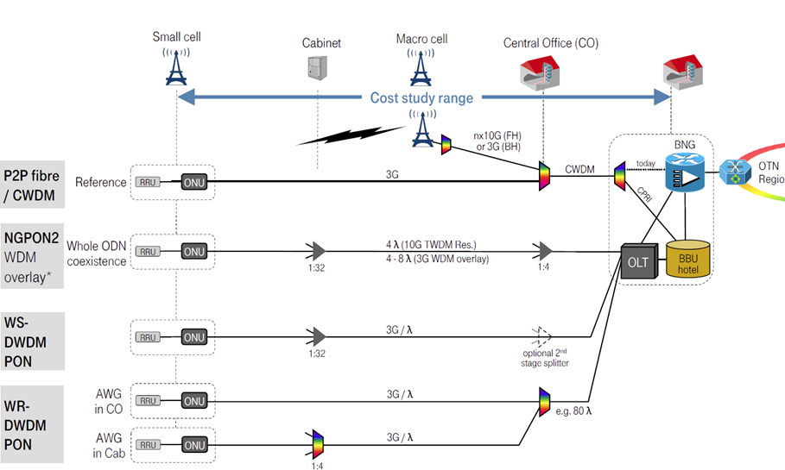

*Figure 6:* *Optical technologies for fixed-mobile convergent access networks*

Several infrastructure studies have shown that due to the LTE HARQ latency restriction well below 1 ms, a BBU or RCC needs to be placed at the Main CO level or even closer to the antenna site.

The focus is then on the following fixed and mobile converged architectures:

* Backhaul with RCC centralised at Main CO
* Fronthaul with both RCC and BBU Hotel centralised at Main CO

CWDM (ou WDM???) is a natural evolution that may be considered for these architectures. As convergence solutions WS/WR-WDM-PON and NG-PON2 can been analysed against this reference (see *Figure 6*). The target in all scenarios is to combine as much as possible all backhaul (fixed and mobile) and/or fronthaul clients on the same transport technology and fibre infrastructure. NG-PON2 is the only transport technology enabling fibre infrastructure- and technology-level convergence. All other solutions require separate fibre infrastructure for fixed residential and mobile fronthaul/backhaul services, allowing “only” technology-level convergence. Note that, from the fixed network point of view, it was shown that as long as the guaranteed constant available data rate for residential access is below 500 Mb/s, a shared medium access in the first mile is more economically beneficial than delivering a whole WDM wavelength with WR or WS-WDM-PON to each residential customer. If one consider both mobile and fixed traffics, this figure may change, depending on the density of base stations and on the proportion of fixed network customers already connected to the fibre.

## Energy constraints

By 2017 [study on [www.gwatt.net](http://www.gwatt.net)], the ultra-connected society will access information in the cloud, mainly from smart phones, tablets and other mobile devices using ultra-broadband technologies.

From the Cloud:

* children will access education through open online courses; people will access healthcare using remote online diagnosis;
* people will socialize on-line, watching video and listening to music;
* companies and organizations will run their businesses.
* users will rely on an average of 5 devices per person, with more than 20 billion devices connected.
* over time, the digital universe will grow by a factor of 32 in 2020 compared to 2012 and mobile data traffic will grow 13 times.

By 2017 more than 5 zettabytes will be stored in the cloud (a zettabyte is a thousand billion gigabytes), the equivalent of storing 10 billion years of music. Information Communication Technologies consumed 6% of global energy in 2013, at approximately 108.4 Gigawatts.

In 2013, devices consumed approximately 39 Gigawatts (1 Gigawatt is the typical capacity of 1 nuclear power plant), the equivalent of 7 New York Cities and world-wide telecommunication networks consumed around 69 Gigawatts (the equivalent of 12 New York Cities) and will reach 167.5 Gigawatts in 2017 (the equivalent of 30 New York Cities).

The following figure shows the weight of different network segments in 2013, worldwide:



*Figure 7 : Repartition of the energy consumption per network segment*

We observe that the periphery of the network is mainly responsible for the major part of the energy consumption: mainly the home & enterprises, the data centers and the wireless part of the access and aggregation network segment.

In parallel we observe that the electricity production reaches limits for many reasons:

* The nuclear power plants development strategy, since the accident of Fukushima, has been reconsidered in many countries, and the new rules to guarantee the security increase the cost of the electricity production.
* The production of electricity using fuel-based plants creates problems in terms of emission of CO2.
* The production of electricity based on renewable energies (except hydroelectricity) is still in a transition phase.

Due to the continuous growth of the traffic volume worldwide, it is then important to better optimize the energy consumption of future products. And ICT represents a non negligible part. The current home boxes or gateways in the apartments are dominating the power consumption of the global telecommunication network and becomes therefore an important topic of research. In parallel Data centers are becoming the second important network segment in terms of energy consumption. And the distribution of data centers in the network will not save energies, and there will be a need for efficient and optimized protocol to minimize the duplication of data in the local caching. The mobile network represents also a critical part of the network that requires new optimizations.

The GreenTouch initiative ([www.greentouch.org](http://www.greentouch.org)) proposed different innovations to reduce the energy consumption. It has demonstrated that it was possible to increase by a factor 10,000 the energy efficiency in the wireless part by adopting new techniques. But even if we have strong well identified weights, we don’t have to neglect the other network segments, more energy efficient because they deal with aggregated traffic, but that could individually provide new interesting features, in terms of power consumption in particular for big systems.

How the optimize the energy efficiency?

Different energy saving solutions have been proposed for wireless access networks, they can be classified into 4 groups: i) hardware design to reduce the BS power consumption, ii) network management strategies regardless to the offered capacity and the actual demand, ii) radio resource management solutions to answer the question: when and how to transmit?, and iv) intelligent network architectures to cope with the traffic growth in a more energy efficient manner.

***The most obvious approach is the sleep mode fonction entering into the category : eco-management.*** Really pragmatic when we are closer to the user, it becomes less evident when we have to put in sleep mode a board processing thousands of clients. The synchronization of traffic transmission/reception may be used to reduce the energy consumed by the Node (e_Node) closer to the user. The design of this closer node to the users must consider the reduction of implementation costs (number of components) and operational costs (specially associated to the energy consumption). The adaptive link rate can be used to allow this process. Efficient and fair DBA (Dynamic Bandwidth Allocation) Algorithms can be used to reach the goal of energy savings in this node [15]. In addition, since the sleep mode is not an on/off mode, the gain in energy efficiency of the system is not so huge. And to enable a sleep mode operation, we need some additional protocols to give orders or information that need to be processed locally, to modify the hardware to support a sleep mode regime, and to modify the rack cooling for big systems to be sure that a board in sleep mode will not impact all the system. New cooling systems could be then mandatory not to impact too much the stability of Carnot cycles, generally created in big racks.

***The second approach is to use renewable energies*** when possible to limit the energy consumption of the network. For example some antennas can be fed by solar panels coupled with batteries, when the electrical power required is in the range of few 10’s of watts.

***The third approach is to adopt the eco-design.***

Environment Conscious Design (ECD), or Eco-design is the application of engineering concepts to minimize adverse, and maximize beneficial, eco-environmental impacts throughout a product's entire life cycle

ECD means applying product life cycle thinking to minimize environmental impacts as early as possible in the product design and development process, while opportunities remain to improve the environmental performance of the product.  ECD involves minimizing energy use and material, and maximizing reuse and recycling. This concept simultaneously improves business productivity and profitability and reduces pollution and resource usage.

The implementation of Eco-Design principles includes the systematic integration of eco-environmental considerations into the product life cycle design and development process. Using this approach eco-environmental aspects are addressed alongside other design considerations, such as product cost, performance, customer requirements, packaging solutions and manufacturability.

Looking at TelCo network equipment, the stage that impacts most the environment is the use phase in the network

Environmentally conscious network operators are committed to reducing the environmental impact of their networks and data centres as their business grows, which together can represent more than 80% of their CO2 footprint. They do so by building more eco-efficient networks, which means investing in more efficient technologies and exploring innovative solutions that cut CO2 emissions by reducing energy consumption and using renewable energy.This approach reduces their impact on the environment and also reduces their operational expenses. The eco-design can lead to a reduction of the CAPEX (introduction cost and cost at the end of life of the product) and of the OPEX (energy consumption, upgrade costs, reliability…).

*Figure 8* shows the different approaches to reduce the energy consumption of products.

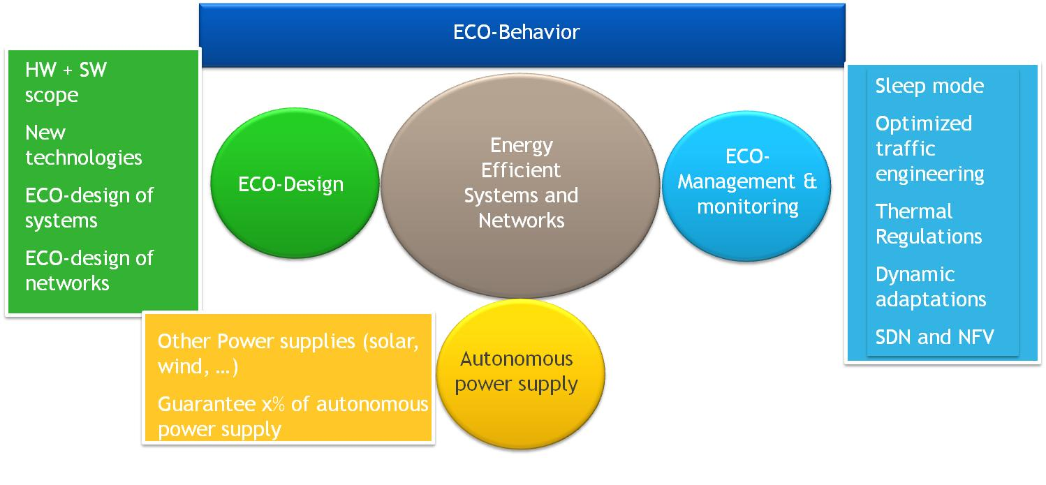

*Figure 8 : Diagram showing the different directions to reduce the energy consumption of products.*

Where eco-design is mandatory?

Eco-design is required for houses and flats to limit the energy consumption. This is a first source of reduction of the energy consumption by educating people and by implementing some automatic sleep mode functions in many devices. For the ICT part, we need to pay attention to the terminals and in particular Personal Computers that are today impacting dramatically the energy consumption. The gateway could be also better optimized by implementing sleep mode functionalities depending on the activity of the subscriber. *Figure 9* shows the weight of the domestic equipments (PC, printers, smart phones mobile phones and tablets).



*Figure 9 : contribution in terms of energy (GW during year 2013) consumption per terminal.*

We observe that the personal computers represent a large part of the energy consumption at home. The venue on the market place of tablets will mitigate this problem. Finally for the ICT Part we need to pay attention to all the network segments to optimise their energy efficiency. Thus, the N-GREEN project targets new solutions for the metro access / aggregation, metro core, core for the fixed networks, and xhaul technologies for the wireless network.

Risks if there is no action in this field:

An important question to be raised is: what is the risk if we don’t care to the energy consumption in general?

*Figure 10* shows the potential impacts at the national and world scale.



*Figure 10 : Some examples of risks in the case of energy shortage*

Directions to optimise the energy efficiency:

The optical technology has a high potential to optimise the energy efficiency of systems and networks. For example an optical gate consuming 1 W, can have energy efficiencies as high as 10Tbit/J, which is several order of magnitude higher when compared to electronic technologies.

The N-GREEN project will be then focused on new innovative approaches, based on hybrid systems (optics + electronics), giving a new long term vision through new business models, targeting also short and medium term use cases based on commercially available devices and components, to design two fundamental sub-blocks of switching nodes: the backplane and the pass-through.

## Current Architecture of Network Nodes

Conceptually, network nodes switch traffic coming from multiple ingress ports to multiple egress ports. These ports may be connected to other distant nodes in the same network domain, or interfaced with end-users’ networks for local traffic. The timescale may be long (circuit switching, typically quasi-static paths established at the network level) or short (packet switching, typically on microsecond scales, with each packet routed independently).

Nodes in current optical networks may perform both circuit and packet switching. They are typically organized around a Reconfigurable Optical Add-Drop Multiplexer (ROADM) supplemented by an electrical packet switch (EPS). Ingress ports carry multiple channels through wavelength-division multiplexing (WDM), which allows an easy separation of channels at the wavelength granularity. For each channel, if all the traffic it supports is bound towards the same egress port (which is decided at the network planning stage), it is circuit-switched directly to that port by the ROADM. If not, the optical signal is sent by the ROADM into a line card that converts it into electrical form (O-E conversion) and separates the traffic into individual packets, which are then passed on to the EPS. All functions required by packet switching are thus performed electronically: label or header decoding, decision of egress port, and buffering.

The addition of a ROADM stage to switching nodes is a recent development: historically, all traffic was electronically switched, with WDM de-multiplexers connecting all channels to line cards­—hence the terminology of “optical bypass” or “pass-through” is to designate the use of a ROADM, because optically-switched traffic bypasses the traditional EPS. While an EPS-based node provides maximum flexibility, its capacity is limited by the number of line cards and their data rate, and especially the capacity of the electronic backplane through which all traffic is routed. It also requires considerable computing power, which grows linearly with the traffic, incurring unsustainable energy consumption.

When the capacity of the EPS node is in the range of few Tbit/s, there is no big challenge.

Beyond 100 Tbit/s of switching capacity, new challenges occur:

* In the backplane of switch/router in terms of reliability (a processing is required at high frequencies to correct the impedance mismatches), complexity of the interconnection (thousands of fibres are required to interconnect line cards), cost (the backplane becomes a big system) and energy consumption (the high frequencies boost the power consumption of the backplane in a non linear way).
* The layer 2 becomes the bottleneck since, by increasing the bit rate per channel the need for intermediate aggregation is more required to improve the network efficiency. Thus, the bottleneck comes from the switching capacity of the layer 2 and its cost.
* The optical transport layer is too static and requires additional flexible interfaces. TRX offering tenability, modulation format adaptation and bit rate adaptation are proposed but impact dramatically the cost of the optical solution.

A key question is then: can we find a new switch/router architecture including an optical transport layer able to support switching capacities beyond 100 Tbit/s?

illustrates the global node structure for the backbone that needs to be optimised to reduce its cost, improve its performance and offer new switching capacities well beyond 100 Tbit/s.

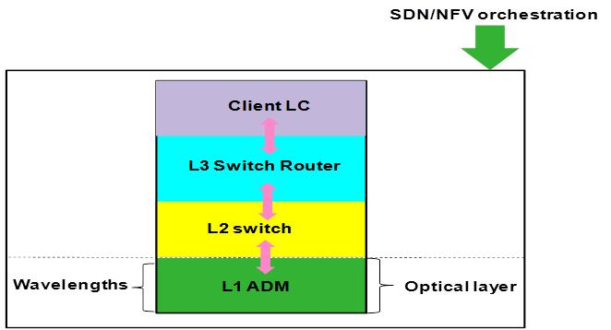

*Figure 11: General node structure*

Although optical packet switching (OPS) solutions have been researched, they still haven’t reached enough maturity that allows plug-and-play replacement of EPSs; in particular, optics has no scalable method of buffering packets (without which the switch is vulnerable to contention) or decoding and processing their headers (to decide where to send them). Therefore, optical circuit switching (OCS) by a ROADM is used instead, which is transparent to modulation and much less energy-consuming—at least for channels whose traffic can be switched whole without a need for packet switching.

This ROADM+EPS configuration alleviates the capacity requirements on the EPS’ electronic backplane, at the cost of added complexity, especially global constraints such as the maximum propagation length of optical signals (in terms of distance and number of nodes traversed), and wavelength continuity (because optical bypass cannot change a channel’s wavelength, and same-wavelength channels cannot be sent to the same egress port). Currently, these constraints are solved at the network planning stage, and OCS remains quasi-static. Attempts to introduce dynamic OCS come up against the absence of use case for this kind of dynamicity, whose speed is (when off-line route calculation is not available) limited by the NP-hardness of the routing and wavelength assignment problem.

What are then the limitations of this technology? The introduction of a flexibility, imposes new transceivers embedding more fonctions, and a new generation of ROADM able to adapt the channel spacing to the demand. A flexibility is required to adapt the resources to the needs that can evolve more frequently in a network supporting distributed data centers. The ultimate functionality is of course the dynamicity to adapt in real time the resources of the network to the needs.

But the flexibility has a cost, and the benefits of a L2 providing additional aggregation made on the top of ROADMs to provide better filling ratio of the wavelengths, to reduce the cost of the optical network can be reduced through an extra cost of the TRX and of the ROADM. Therefore, it is important then to identify an alternative offering network efficiency at a lower cost. The N-GREEN project, through a low cost approach and a packet-based concept, is targeting this goal.

## Emergence of new control plane technologies

## *Objectives of emerging SDN and NFV paradigms*

All communication nodes have to implement forwarding rules, i.e. methods for selecting a given output link for each incoming packet. Forwarding rules may depend on input link, on characteristics of the relevant traffic flow and on policy rules specific to the network, and relative to e.g. authorisation, security, QoS, etc.

Different technologies use different methods for deriving these forwarding rules. Typically, forwarding rules in IP networks are derived from routing protocols, forwarding rules in MPLS networks are derived from the definition of LSPs, and Ethernet forwarding rules are dynamically learned by observing received packets and linking their source address with the used input link. What is common in all these methods for deriving forwarding rules is that the actual derivation process is distributed, and that equipment individually maintain their own forwarding table, i.e. the set of all current forwarding rules.

More generally, the creation and maintenance of a forwarding table is part of the control plane. Current communication equipment perform both forwarding (data plane) and control plane functions. The interfaces between control and data planes are proprietary and depend typically on the version of specific equipment. Moreover, the expression of policy rules is also proprietary, which makes deploying global rules over a network a significant configuration problem.

SDN relies on data plane and control plane functions being realized in different equipment.

* Data plane functions, such as policy enforcement or forwarding, are performed in network devices that are externally controlled;
* Control plane functions, such as access control or path computation, are performed in so-called SDN controllers, which maintain a global view of the network. SDN controllers pilot forwarding and other data plane functions thanks to a protocol such as OpenFlow over the so-called southbound interfaces (interfaces between the SDN controllers and the network devices);
* Open interfaces (APIs) are made available on the controllers to allow the application layer to program the SDN controllers over their northbound interfaces.

This is illustrated in *Figure 12*.

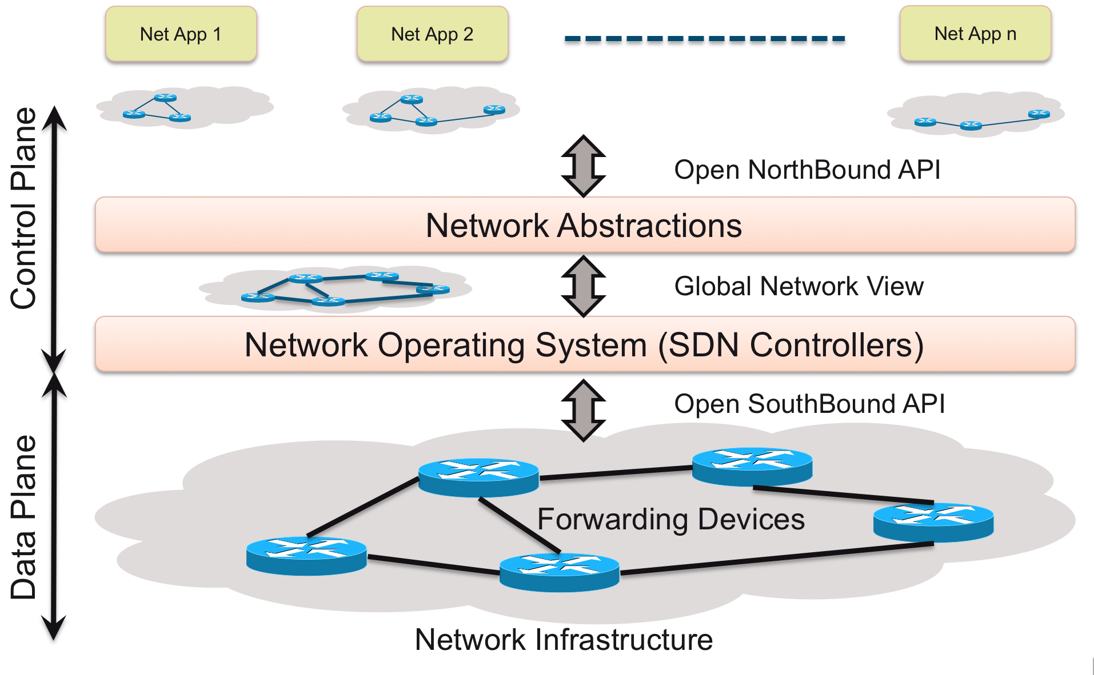

*Figure 12 : SDN based controlled Infrastructure*

As mentioned earlier, SDN separtes the control plane from the data plane in order to form a domain wide view of the network and programmatically controls network resources and traffic flows. NFV creates a very dynamic network environment and can deploy network services in software on demand in physical infrastructures. SDN and NFV are becoming less distinguishable as independent paradigms as they are naturally complementary and combine into a unified software based networking paradigm. The SDN controller maps well to the overall concept of network controller in the NFV architectural framework and specifically maps as a component of the NFVI (Network Function Virtualisation Infrastructure) network domain. When SDN and NFV are combined, the SDN controller can work with orchestration systems, control both physical and virtual switching and can provide the necessary comprehensive network monitoring. An SDN controller can also run in a VM and can thus be managed as a VNF (Virtualised Network function) with other VNFs in service chains and service orchestrations. Hence, SDN controllers in VMs can also take benefit directly from NFV-MANO (Management and Orchestration). The N-GREEN project foresees the joint use and combination of SDN and NFV to achieve both node level and network wide control in future generation optical networks.

## *Examples of current SDN control in Optical Networks*

SDN concepts have been applied traditionally to the packet portion of the network as optical transport could not be programmed. New advances in optical technologies to some extent can now allow control and configuration (programming) of the optical layer.

A few examples, of the current state of the art, of features that can be modified and configured via a SDN control plane comprise:

* Software-defined optical port speeds, protocols, and wavelengths
* Advanced modulation and detection schemes, at 100 Gbit/s and higher speeds
* Flexible wavelength grids whenever a Flexgrid approach is adopted (note that this is not the advocated and privildged mode for the N-GREEN nodes that favour fixed organizations and rely on the use of colored packets)
* Flexible wavelength routing via flexible ROADMs
* OTN grooming and switching

Using these programming capabilities and abstracting the optical transport to a pool of shared resources can enable the dynamic and on-demand allocation of resources. Using SDN also enables (facilitates) joint management of packet and optical networks. A logically centralized control (typically a set of distributed and cooperative controllers is used to achieve the unified and global view advocated by the basic SDN concept definition) can be aware of all the IP packets and optical resources and use them efficiently for dynamic and flexible service creation and provisioning.

This coordinated and unified control enables more efficient resource utilization and service orchestration. This assumes that both a northbound orchestrator and applications are designed to make use and take advantage of this centralized control. In addition, on the southbound, below the logical SDN controller, the switching, routing and networking technologies are designed to interact with the control plane. Control and configuration languages and interfaces are needed between the SDN control plane and the switches. This puts automatically a requirement on the N-GREEN switch/router north interface and compatibility with the selected protocols and languages on the SDN controllers to switch interface.

The OIF Carrier WG Requirements on Transport Networks in SDN Architectures proposes two models for SDN-controlled transport networks.

In one model, the SDN controller directly controls each node in the network, including the optical nodes and puts requirements and expectations/roles on the involved network entities:

* Each network element needs to support a transport programming interface, such as OpenFlow/OF-CONFIG or Netconf (and possibly configuration languages such as Yang)
* The SDN controller has to communicate with each network element to provision an end-to-end service
* The SDN controller has to be aware of the detailed topology and the optical switch technology. This means that all the involved switches have to declare and announce themselves, their capabilities and scope (ports and connectivity)

In the second model, the controller controls a multiple network domain and offers an integrated network view. The multi-domain network (?? Peut-on préciser multiple network domain et multi_doamin network?) is abstracted and appears as a single, flat network for applications. Each domain has its own choice of control – dynamic routing, GMPLS, or SDN. The second model represents a more evolutionary approach towards optical SDN. In ONF, the work on OpenFlow extensions for transport networks is still underway. Service providers can implement SDN gradually to avoid network instability by deploying SDN segments alongside existing network control protocols. This model is also in line with the MEF Lifecycle Service Orchestration (LSO) architecture organized in element management, infrastructure management, and service management layers. This second model points out a number of additional requirements that N-GREEN will have to take into account to achieve network wide control and management:

* Automatic discovery of network topology and updates when the topology changes
* PCE (Path Computation Engine) – computation of paths based on routing and optical domain constraints
* Allocating resources and provisioning circuits based on the computed path
* Automatically restoring service on a network failure by providing an alternate path
* In this case the multilayer SDN control has also to act as the domain gateway controller that functions as a gateway for domains controlled by distributed protocols such as GMPLS.

## *Objectives for the N-GREEN nodes and networks*

From the N-GREEN project point of view, the minimum requirements for the N-GREEN node and network level control and management is to provide at least the following capabilities and interfaces towards the SDN and NFV management planes depicted in :

* An OpenFlow/OF-CONFIG, NetConf, SNMP or any other protocol agent for optical switches and especially the N-GREEN switch/router;
* The ability to inject rules into the switch for flow control and steering;
* The ability to express configuration actions via a selected southbound language for configuration of the switch. A language like Yang is a candidate for this interface assuming that it sufficiently compatible or transformable into legacy languages and protocols in order to unify the interaction between service orchestration and management and the switch/router;
* Management of network and node level resources including:
  + load management and balacing,
  + traffic engineering,
  + On/Off/standby operation mode control;
* Internal signaling and control, including header control operating on isolated out of band wavelength as well as waveband splitting between the FlexGrid and the Optical ByPass subbands in order to partition the optical spectrum according to tenant and applications flow requirements;
* Reservation of resources;
* Protection of data;
* Fall back mode with the ability to deactivate line cards for instance when they experience a failure so N-GREEN nodes transfer in transparent mode the flows though the optical bypass without forking a copy to the electronic boards and processing until the line cards are activated again after replacement or repair;
* Probes and embedded monitoring in order to collect and transmit key performance indicators to the SDN controller so corrective and management actions are decided out of band to maintain service level agreements at node and network level. For this purpose interfaces to feed the monitoring plane and the SDN/NFV management framework are required in the N-GREEN nodes;
* etc…

Relying on the architecture diagrams presented in , the candidate components for dynamic configuration via an SDN/NFV management plane could be the:

* Containers;
* Line cards;
* Monitoring units;
* Electrical switch for load balancing for the by-pass technology;
* The N-GREEN optical switching matrices also via the electronic boards.

The decisions for the configuration and control of the optical switches and the control and management of application flows will be typically handled by an orchestrator associated to the decision engines in the SDN and NFV management planes. All of these decision points will be located at the switch –router northbound and seen as northbound applications from the SDN controller standpoint. A figure represents this high level decision framework needed to control the node and network level topologies according to demand or adaptation for restoration or fault management.

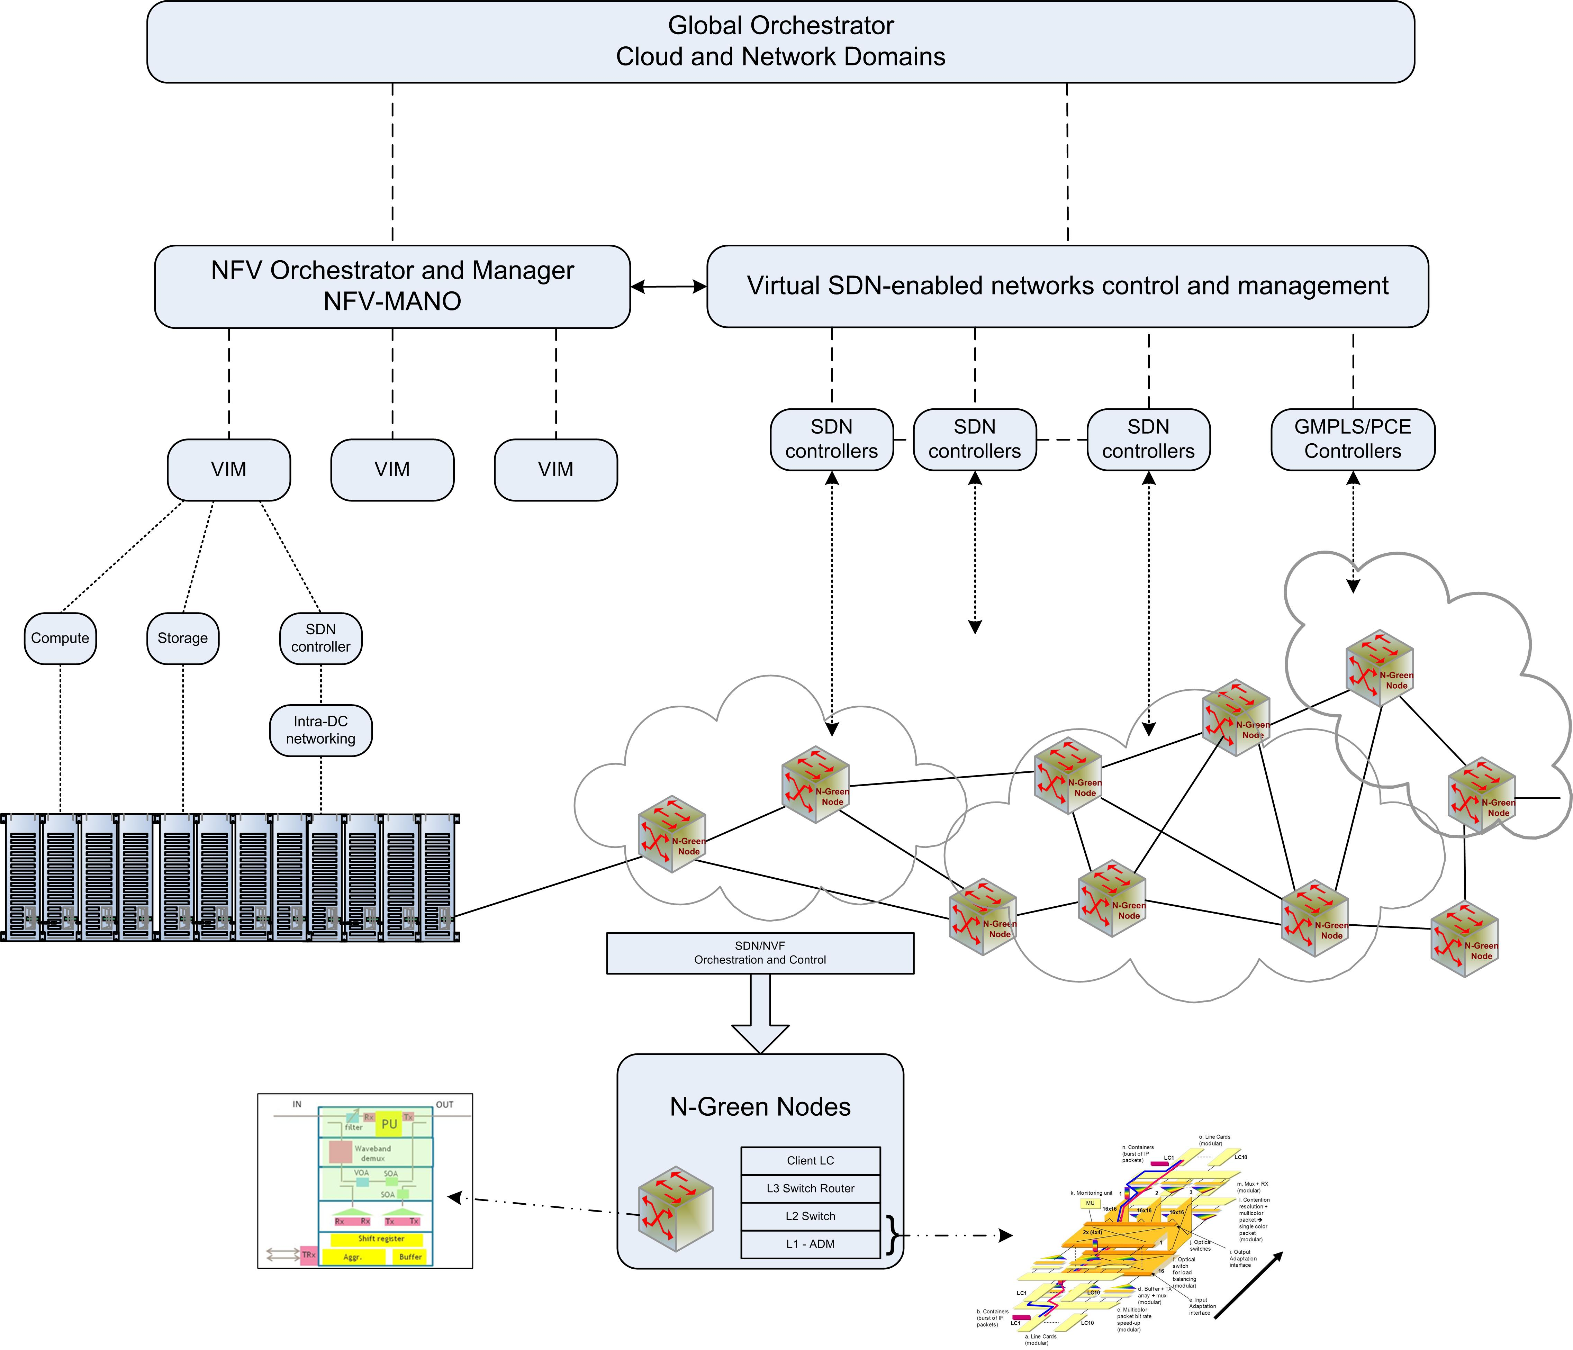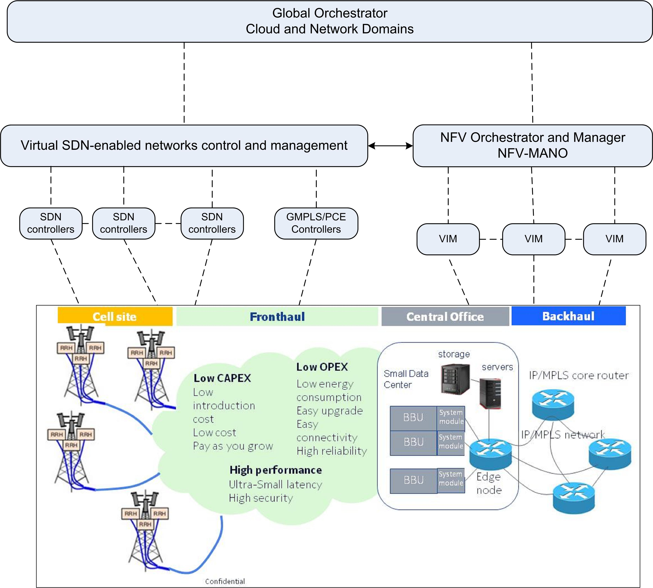

*Figure 13. SDN/NFV framework for the control and management of N-GREEN oriented networks*

## Recent Technological advances

In addition to advances in the control plane, a number of recent technological developments may act as enablers to OPS, or at least to a redistribution of roles between electronics and optics that better leverages the latter’s lower energy consumption per bit transmitted. These developments concern both physical devices and network architectures. In this section we will first give a brief overview on recent advances in both fields and then discuss with more details the state-of-the art of two slotted optical sub-wavelength switching architectures, to which several partners of N-GREEN have contributed. Indeed, we will see in the next sections that N-GREEN approach intends to capitalize on their achievements but aims at using more mature and cost-effective technologies.



## *Advances on devices*

The components and devices are strategic to build a low cost solution. Recently a strong emphasis was made on new components for the NG-PON 2. These advances creates then new opportunities for the new generation of low cost networks.

Concerning the transponders, we can list WDM devices. Effect Photonics, a Dutch SME (Small and Medium sized Enterprise), proposes a new generation of low cost products, based on directly modulated lasers or externally modulated lasers for longer distances of propagation. *Figure 14* illustrates the devices realised by this company:

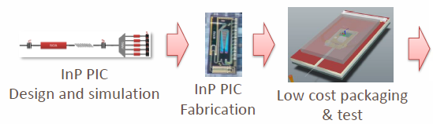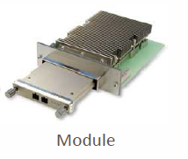

*Figure 14 : CFP2 module for low cost (< 1k€) and low power consuming TRX (< 12W)*

For the switching device:

* Optical gates, based on a SOA technology, are considered. Reflective Semiconductor Optical Amplifiers (R-SOAs) are already installed in WDM PONs and could be good candidates for low cost optical gates (few 10’s €). *Figure 15* shows a R-SOA SFP module for a direct OOK modulation. In our project, this R-SOA could be used as an in-line amplifier and an optical gate.

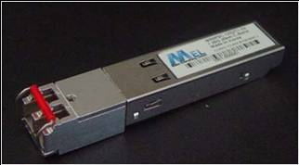

*Figure 15: Mel WR32 RSOA-based transceiver*

* If we consider fast optical switch, we can find on the market place, 4x4 optical switches from Venture Photonics (see *Figure 16a*). Higher sizes are investigated by different universities. One of them is Tu/e (Technische Universiteit Eindhoven), which has already realized a 16x16 switch. *Figure 16b* shows the realized components.

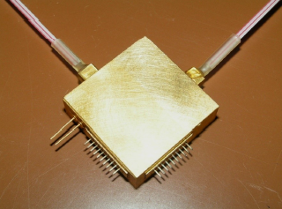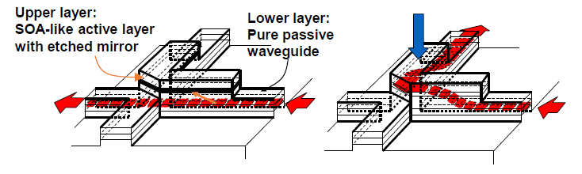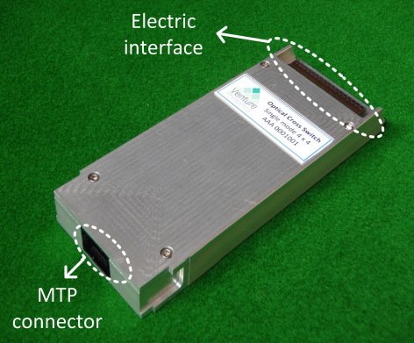 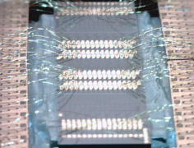

*Figure 16 : a 4x4 switch from Venture Photonics(component, principle and final module), b: 16x16 switch from Tu/e (chip with ribbons)*

## *Advances on switching architectures*

Fast optical switching systems have been investigated for a long time. The main brake for their emergence in products was the lack of optical memory to have the same functionalitiy than a pure electronic system.

To compensate the lack of optical memories, different options have been investigated. The first one was the use of optical fiber delay lines, as delays to solve the contention in real time. Even very simple to implement, this type of buffering cannot offer the full flexibility of electronic memories. Then Prof. Jonhatan Turner from Washigton University and Prof. Chunming Quiao from Suny Buffalo proposed a new concept ; the burst switching [16]. It consisted in anticipating the collisions thanks to a header sent in advance. However this technique can offer packet loss rates that cannot support high quality of services requiring low packet loss rates.

Therefore the scientific community investigated in two main directions:

* ***Hybrid NxN switching systems***, combining fast optical space switching (using pure space switching or spectral switching) and electronic memories. This was the case for projects like the RNRT ROMEO (2003 – 2005) or the project of NTT called Hybrid Optical Packet Router (HOPR). In this approach the connectivity can reach high values. The difficulty to justify an optical switch when imposing an opto-electronic conversion at each port has pushed the community to position the electronic buffer as a shared buffer to offer a transparency for the packets that have no need to cross the electronic buffer. But in these approaches, the crossing of the buffer is conditioned by a statistical contention issue and is then directly dependent to the load. If the load is high, then we loose the benefit of the transparent paths since the majority of the traffic will have to cross the electronic buffer. These architectures are still investigated for the metro and core networks but also for the data center intra connection.
* ***Fast optical add/drop multiplexers***, reducing then the contention to an order of 2. This technology is quite interesting since there is still an electronic buffer for the add and the drop part of the system, but a large part of the traffic can cross transparently the system offering new benefits with respect to a NxN system. However a NxN system can be build with this OADM technology by having different boards (each of them being an OADM) interconnected with an electronic switch. The benefits are the followings: the contention resolution is as efficient as for full electronic systems since we are using an electronic memory for the insertion of a packet on the fiber. The crossing of the electronic buffers is only manadatory if we want to change the fiber (we need then to go back to the electronic switch). Finally for the passthrough all the packets can stay in the optical domain, provided that that can stay on the same fiber or we don’t need to drop them. These architectures include Optical Burst Transport Network, proposed by Huaweï [26], and also:
  + Packet Optical Add/Drop Multiplexer technology (P-OADM) firstly proposed by Bell Labs, and studied in the DAVID project (2000-2003), in the ECOFRAME (2007-2010), in the ALPHA (2008-2011) and finally in the SASER (2012-2015) projects.
  + Time-Wavelength Interleaved Network (TWIN) concept based on a global scheduling for the contention resolution and resuse the already installed R-OADM in the optical network has been proposed by Bell Labs in 2002 and more recently investigated by Orange Labs.

These technologies are described in more details in the next sub-section.

Here we provide some concrete recent examples of technologies which have been investigated:

Hybrid opto-electronic packet switching consists in handling OPS’ vulnerability to contention by storing packets into a shared electronic buffer [16], [21]. Telecom ParisTech and Telecom SudParis's ongoing activity on this topic [22], [23] [24] ] explores the “sweet spots” where this configuration has a low Packet Loss Rate (PLR), acceptable for deployment in practical networks, while also keeping the number of O-E conversions, indicative of energy consumption, significantly lower than that of conventional electronic switches.

Handling contention in higher network layers: in the specific case of OPS in data centers, it has recently been found [25] that OPS doesn’t have to handle contention by itself; it may be handled at higher layers by configuring TCP connections for Stop-and-Wait (SAW) rather than more conventional sliding windows. How this applies to global networks, with longer propagation distances, remains to be investigated.

Synchronous network architectures: up to the metropolitan scale, it is now feasible to synchronize entire networks down to nanosecond scales using affordable atomic clocks or external signals from global positioning systems such as GPS, GLONASS or GALILEO. This in turn enables architectures based on optical slot switching (OSS) where packets occupy specific time slots. All switching decisions can then be distributed over the network and sent to each node over a dedicated lower-bit-rate control channel, in terms of where to switch each time slot of each channel, instead of having to decode and process each packet’s headers in the node.

## *Example of Optical slot switching architectures: POADM and TWIN*

Among OSS architectures, two solutions have been particularly investigated in the last decade, as they are particularly suited to provide end-to-end slot transparency. These architectures are called POADM (Packet Optical Add-Drop Multiplexer) and TWIN (Time Wavelength Interleaved Network). Both solutions could serve to provide a sub-wavelength optically switched transport layer, as an alternative, to e.g. OTN or Ethernet (see *Figure 17*).



*Figure 17: layer model showing the possible position of POADM or TWIN technologies*

Packet Optical Add/Drop Multiplexing (POADM) [27][28][29] is a ring slot-switched solution. It was originally designed to be deployed in a WDM ring network operating at 10 Gbit/s over 40-wavelengths. A study in [28] demonstrates the feasibility of a bit rate transparent ring based on POADM up to 100 Gbit/s.

The slot lasts 10 µs and can transport only one burst. Each burst includes at least: one guard band, one preamble, one synchronization word and a payload. Dummy bursts are generated when no traffic is sent in the network to simplify the power management in the ampliﬁcation stages [27]. POADM uses a dedicated control wavelength that can be at a different bit rate than the data. The control message is composed of global control ﬁelds informing about the synchronization, the packet length, the error correcting code and the ring identiﬁer. Furthermore, it includes at least 40 interval times representing the headers of bursts on every wavelength of the same time slot. These interval times are followed by one additional interval time for the network management and one extra interval time to transport any extra information.



*Figure 18 : POADM node structure*

The POADM node ensures the emission, the transit and the reception of bursts. The structure of this node has been described in [28]. It consists of one WDM ampliﬁer at the input and another at the output to manage the power budget and enable the cascade of several nodes. Incoming bursts, after pre-ampliﬁcation, are optically de-multiplexed according to their wavelength. Besides, each burst passes through an optical coupler that splits it into two identical bursts. The ﬁrst burst is dropped by a ﬁxed wavelength receiver. Only the bursts that must be dropped are processed and the others are discarded. In the transit line, the second burst crosses an optical gate. According to the control plane instructions, optical gate could be in ON state to let bursts pass or in OFF state to suppress them. Afterwards, all bursts are optically multiplexed and ampliﬁed again. New bursts from the add port can be re-inserted at any wavelength using a Fast Tuneable Laser (FTL). Meanwhile, the control packets are detected, to properly adopt the required switching patterns for the optical gates and for the tuneable lasers.

Performance of POADM depends on the used MAC protocols. Authors in [30] use a totally opportunistic and distributed protocol to attribute resources. Without considering bandwidth loss due to guard time between optical packets, the average wavelength occupancy of their solution is up to 80%, whereas the maximum occupancy can reach 95%.

Time-domain Wavelength Interleaved Networking (TWIN) was originally invented by Bell Labs . This network architecture can provide ﬂexible connectivity using passive optics in internal nodes. Indeed, a particular wavelength is attributed to each edge node to receive its data. When a source has a burst to send to a given destination, the source tunes its laser to the wavelength uniquely assigned to that destination for the duration of the burst (

*Figure 19*). The intermediate nodes steer optical signals passively from their inputs to their outputs based on the colour of the burst. Thus, the virtual topology of TWIN can be viewed as overlaid optical multipoint-to-point trees. To perform automatic discovery of resources, routing and signalling, TWIN adopts a separate control plane by allocating a dedicated wavelength for this purpose.



*Figure 19: Illustration of TWIN principle and scheduling*

In TWIN, the complex processing functions are pushed to the network edge. Edge nodes utilize burst-mode receivers and fast tuneable lasers, whereas, intermediate nodes consist of a passive wavelength switch, i.e. Wavelength Selective Switch (WSS), capable of merging and routing incoming wavelengths to the appropriate outgoing ports. The cross-connect conﬁguration stays the same at very long time scales since reconﬁguration is only needed when a failure occurs or a new connection requires a new branch of a tree to be created.

The fact that all sources share the same medium to reach a speciﬁc destination leads to possible collisions at each merging point of the tree. To resolve this problem, TWIN relies on a complex scheduler to coordinate sources transmission. The control plane can be centralized [33] by using a single control entity or distributed [34] by using a control entity per destination. The transmission to a given destination is organized in repetitive cycles. A cycle consists of a predeﬁned number of slots and each slot carries exactly one burst. The purpose of the scheduler is to assign, in each cycle, the appropriate slot(s) to source-destination pairs to avoid collisions. The centralized scheduler is performed in a particular control point within the network. The control point gathers all necessary information (e.g., traffic demand matrix) and processes it in a relatively long time interval. Then, it computes the slot allocations to each source-destination pair eﬀectively and it sends it to the edge nodes via an out-of-band control channel. The distributed scheduler is suitable for asynchronous traffic with dynamic bandwidth requirements. For faster response time, a control point is located in each destination and it independently attributes slots to sources that are transmitting to it, based only on source resource requests. Thus, a source may receive multiple grants that call for it to transmit simultaneously, which can create conﬂict. Algorithms have been proposed [35] for a congestion control protocol.

In [36], authors introduce a novel variant of TWIN based on assigning a wavelength per source (instead of the destination) in such manner that source becomes the root of a multipoint-to-point lightpath shared by all destination nodes. Tuneable transmitters and ﬁxed-wavelength receivers are replaced, in the new variant, by ﬁxed-wavelength transmitters and tuneable coherent receivers.

TWIN and POADM show some similarities: both of them perform transparent grooming without any burst collision thanks to a robust control plane. Furthermore, they consist on a fast tuneable transmitter at the source side and a ﬁxed wavelength receiver at the destination side.

However, signiﬁcant diﬀerences exist and are mainly related to the fact that TWIN is suited to a mesh network topology whereas POADM is intended to a ring topology (for transparent operation). Besides, in TWIN, one or more wavelengths are exclusively attributed to a given destination and cannot be used by others while, in POADM, many destinations can receive from the same wavelength, at the expense of using active nodes including fast optical gates. In both cases, the slot allocation is non-separable from the network planning, and the network conﬁguration has a strong impact on the network performance [30], [37].

From a node structure point of view, TWIN and POADM aim to minimize electronic switching and power consumption by resorting to the optical transparency for transit traffic [38], [39]. An appealing property of TWIN is its entirely passive core infrastructure: the electronic processing of the traﬃc is performed only at the edge node when inserting or extracting the optical bursts. The fact that TWIN core nodes are entirely passive do not obliged them to be synchronized with the transit traffic. This property alleviates the synchronization constraints and pushes them to edge nodes where time synchronization should be ensured in order to accurately follow the schedule pattern [40]. Then, the core part of the network composed of inexpensive and passive optical elements, such as couplers and splitters that do not need computation capacities and do not consume lots of power. POADM intermediate node is not entirely passive, but remains more energy eﬃcient than traditional ROADM and Ethernet over WDM solutions [38]. The POADM node should be synchronized with all the other nodes in the network and should have an accurate knowledge of the transit slot timing in order to allow the opportunistic access to the vacant slots without any collision.

From protection point of view, POADM ring is bidirectional in such a way that in case of link failure, a part of traffic is rerouted in the opposite direction, which yields for a need of additional bandwidth reservation [41]. This bandwidth shall be available at every moment, but its quantity will depend on the protection scheme that is used. For TWIN, several alternatives of protection exist. The main difference between those alternatives concerns the degree of resource sharing (emitters, receivers and wavelengths). The higher the degree of sharing, the more complicated the scheduling computation.

The considerable amount of studies performed on TWIN and POADM technologies has shown that both have the potential to provide all functional features to achieve carrier-grade operation (no loss, low latency, limited jitter, fast protection), at least in metro networks. However, their deployment necessitates complex optical devices, such as fast tuneable lasers, which are still costly and difficult to use in operational systems. Moreover, the POADM concept involves cascading many de-multiplexers, which implies very strong requirement on the channel wavelength accuracy. And, in a conventional POADM node, many SOA-based optical gates are required, as they operate on a single wavelength.

We will see in the next sections that N-GREEN approach intends to capitalize on some achievements of the POADM technology but aims at avoiding using fast tuneable lasers and at better using the bandwidth of optical gates by choosing a WDM packet structure.

# N-GREEN Targets

## Use cases

N-GREEN targets three uses cases:

* Use case 1: A low cost solution, competitive with Ethernet technologies, based on a physical ring topology for the metro area. Optical technologies should be used to minimise different costs, in particular the introduction, the end-of-life, the maintenance, the upgrade and the power consumption costs. The network segments targeted are: the metro access/aggregation for the wireline part, the fronthaul and the backhaul links for the wireless part.
* Use case 2: New solution for the metro core and the backbone, supporting mesh topologies, to implement high capacity dynamic bypasses, in order to offer an efficient interconnection layer for inter-data centre communications.
* Use case 3: Modular high capacity backplane for the interconnection of line cards inside a switch/router. The objective here is to find a new technology approach to reduce the physical constraints, to increase the compactness of the global system, to offer new perspectives of capacity growth through a hybrid backplane.

## Investigated solutions

Alcatel-Lucent Bell Labs France, proposed a new hybrid technology, based on low cost and low power consuming optical technologies. It is worth noting that this technology has many similarities with the one proposed by the group of Thomas Pfeiffer from Alcatel-Lucent Bell Labs Germany in the context of metro/access networks [44], [45].

To address a low cost technology, we have adopted the following technical directions:

* Adoption of the less critical devices and the more simple devices
* Adoption of integrated techniques
* Better exploit the WDM dimension to reduce the number of components required in a system
* Use, when possible, components and devices designed for the access segment
* Propose new systems and new network concepts, having a high potential to reduce the CAPEX and the OPEX

For the CAPEX, we target in N-GREEN the smallest introduction cost, and the smallest end-of-life cost, for the product.

For the OPEX, we target the smallest energy consumption (indirectly the highest energy efficiency), the highest reliability (though a better MTBF) to minimize the cost maintenance and the smallest expensive upgrade.

The first proposed innovation in a dynamic transparent optical bypass called WDM Slotted Add/Drop Multiplexer technology (WSADM).

The second proposed innovation is a self-protected backplane for ultra high capacity switch/routers.

Dynamic optical bypass: WSADM technology:

This technology is supposed to replace the current ROADM + L2 switch through a massive integration of the functions and components into a new system design. We propose also to reduce as much as possible the functionality of the components, to adopt the most simple, the most robust and the less expensive components.

At the technology level, the WSADM technology is only based on:

* Semiconductor Optical Amplifiers (used as optical amplifiers and optical gates) that could be R-SOAs already used in colourless access network concepts or based on classical linear SOAs. The main advantage of SOAs is that they are small in size (few 100 µm), they can provide enough ON/OFF ratios,to make negligible the coherent crosstalk and they are wide band to support a WDM regime.
* Lasers and photodiodes arrays with integrated Mux/demux, to minimise the cost per lasers/photodiode through a monolithic integration. We target also fixed lasers and relaxed constraints on the wavelength stability.
* Waveband optical de-multiplexers, to facilitate the cascade of nodes, and relax the constraints of stability of the filtering function but also of the lasers stability.
* For the load balancing, in the case of multiple sub-bands, we propose the use of an electronic switch at the client board level. Thus in this approach the switching is partly done in optics, and partly done in electronics.
* A header processing made at a very low bit rate, through the adoption of a control channel transported on a separate wavelength. The bit rate of the control channel is then independent to the bit rate of the data and can be maintained at a very low value.

Concerning the node model, we propose to structure the node in three layers:

* A transparent layer, going up to the layer 2 (the data link), adopting colourless optical technologies independent to the modulation format, to the bit rate or to the protocols for the data paths, and a coloured interface, at a fixed bit rate, responsible for the scheduling of the system to read and process the control channel.
* A coloured O/E and a colourless E/O interface plus electronic sub-blocks forming the line cards of the system for the add/drop part of the system. These boards are designed for a specific bit rate/modulation format to offer the required flexibility and modularity in the upgrade.
* Interfaces for the interoperability of the system with the client layer.

Finally at the network model level, we propose:

* A ring or a bus topology
  + For the ring topology, a double bus to enable the bi-directionality and offer then an efficient 1+1 protection plane.
  + For the mesh topology adopting the bus approach, a simple node structure.
* A packet format based on a fixed duration (10µs in the edge cards and then transformed into a 10x1µs slot), encoded over 10 wavelengths.
* A control channel on a separate wavelength transporting the header of the WDM packet and all useful information for the network.

*Figure 20a* gives the global structure of the node proposed whereas *Figure 20b* gives one example of a simple implementation scheme.

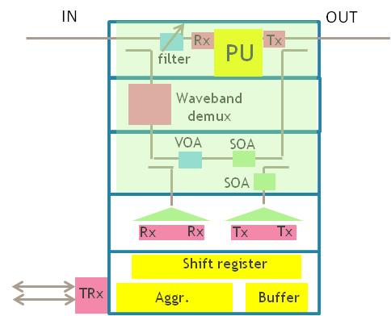

*(a) (b)*

*Figure 20: (a) Global structure of the node, (b) simple implementation scheme*

Self-protected WDM backplane for big switch/routers:

This technology, exploits also new optical technologies, supposed to be very cheap, and with a high potential to reduce the complexity of the optical wiring within a system. We proposed also a self protected scheme in order to avoid the duplication of the full switch/routers in the field. Thus if we target an external switching capacity of 160 Tbit/s, the internal switching capacity is close to 1 Petabit/s (960 Tbit/s exactly) with the adopted protection scheme.

In summary the aggregated switching capacity in the core of the switch routers is done with optical switches (in this project the objective is to explore the potential of a 16x16 and 4x4 optical switch) independent to the modulation formats or bit rate, and flexible and modular electrical line cards and interfaces to manage the input data, process them, encapsulate them into a contained, segment the container to create a parallel slot, and encode them onto 10 wavelengths. In the optical part, we exploit the potential of optical technologies to process the signals directly in the WDM domain. *Figure 21* gives the global schematic of the backplane structure targeting a low CAPEX and OPEX when compared to existing solutions.

*Figure 21 : Description of the structure of the proposed backplane*

## Expected results

The expected technical results of this project are the followings:

* A physical feasibility study, to analyse the physical limitations of the concept. We have identified in particular the Coherent XT, the FWM, the cascadability and the dynamics for the design of a network. This feasibility study will include also the realisation of switches and their test in a system environment.
* A performance analysis to quantify the packet low rate and the end-to-end delay. This study will bring also important information to proper design the buffers and the mechanisms required to minimize the end-to-end delay.
* A benchmarking analysis, to compare this solution with already existing solution deployed in the field: mainly the Ethernet technology, the ROADM technology and solutions in current studies in the research labs, like the POADM technology.
* A guideline to follow to go a step ahead in the process of industrialisation, mainly the standards, and the business model.

Besides these technical results we expect publications, presentation of the N-GREEN results in workshops and conferences, to share this information with the scientific community to create the conditions of a multi-vendor environment.

# Requirements for the N-GREEN Network Solutions

## Main network objectives

The proposal of the N-GREEN concept is born from a long term vision and the identification of intermediate introduction scenario to boost the market with new disruptive solution covering different network segments with a new track: from the access to the core, to identify solutions based on low cost optics pulled by NG-PON2.

In this paragraph we will then list the high level objectives, that will be applied to any network segment (from the metro to the core part of the network).

The characteristics of the networks will cover mainly the topologies, the fiber infrastructure, the nodes structure and its control plane for the macro analytic part.

The switching granularity as well as the QoS, the protection issues, the robustness and the easy upgrade will be considered in this project, to really indentify breakthroughs.

*Figure 22* is showing this roadmap, where N-GREEN is positioned

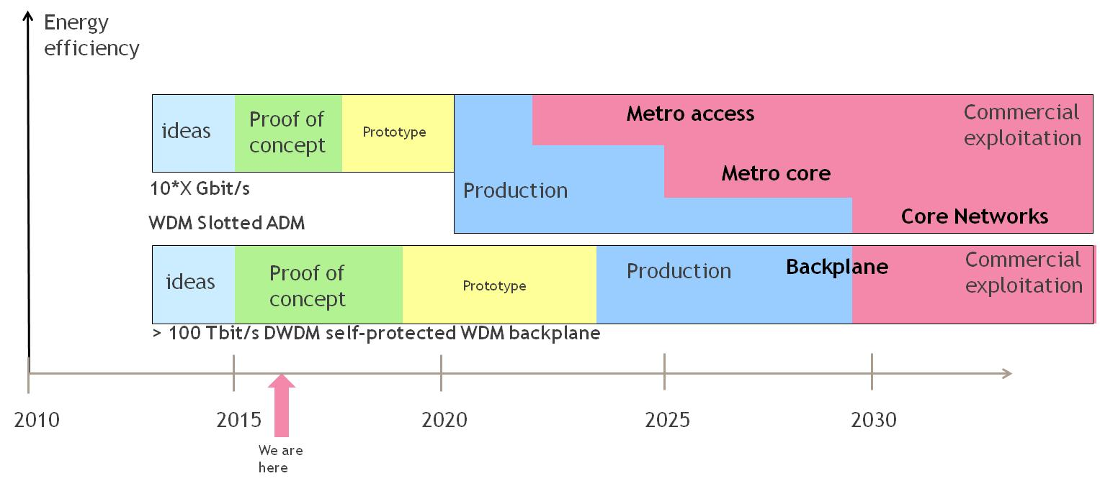

*Figure 22: Long term vision for the disruptive technology proposed in N-GREEN*

N-GREEN is proposing a generic packet technology for the metro but also for the core part of the network. Other technologies have been identified as disruptive technologies pointing mainly the optimization of data centers or high capacity switch/routers based on a new business model. So N-GREEN is positioned in the medium and long term perspective and capitalizes on low cost technologies developed for the fixed access part. In summary, N-GREEN is proposing a long term vision, with intermediate introduction scenario to progressively introduce this new technology on the market place.

We have then distinguished the general specifications that are quite independent to the requirements per network segment and the specific requirements per network segment. The following table summarizes the targets for the general requirements:



*Table 2: General network requirements*

We notice that we have a strong objective, through the rapid introduction on the market place of a new packet technology. This technology should be better in performance and in cost than the classical Ethernet technology and should be based on a technology already available on the market place.

To achieve this, we target a low cost approach based on 6 directions:

* introduction cost, life cost and end-of-life cost for the CAPEX.
* upgrade, robustness and energy consumption costs for the OPEX.

## Specific objectives per network segment

This paragraph gives some objectives in terms of requirements per network segment.

We distinguish then :

* The fronthaul
* The metro access/aggregation and the backhaul
* The metro core / backhaul
* The core network

The table of objectives per characteristic is given in the following table:



*Table 3: Main objectives per network segment*

This table gives the main guidelines for a proper design of the network per network segment. To meet the 5G requirements, the end-to-end latency is a strong objective.

The switching granularity is an outcome of previous projects, in particular the ECOFRAME project where a value of 10µs for the duration of the packet was identified. This value is a trade off between a smaller enough packet duration to minimize the waiting time, and a bigger enough packet to absorb different constraints of the optical technology.

We are considering here add/drop structures for the management of the passthrough traffic, and more than 100Tbit/s backplanes to switch ultra high data capacities in a flexible way while paying as you grow.

# Requirements for the N-GREEN Node Solutions

The requirements for the N-GREEN node solutions must address the two main innovations of the N-GREEN node i.e. the WDM Slotted Add/Drop Multiplexer (WSADM) featuring dynamic L2/L1 optical bypass and the Ultra-High Capacity WDM Backplane (UHC-WDM-B) for the interconnection of line cards (*Figure 23*).



*Figure 23 : General figure showing three proposed innovations. Only two of them will be investigated in this project: the dynamic optical bypass and the high capacity backplane.*

These requirements will concern the data plane, the control plane and the management plane of the N-GREEN node.

1. Concerning the WSADM (optical pass-through):

* The WSADM will adopt a POADM structure and will consider multicolored optical packets based on *WDM time slots* composed with 10 times 1s time slot over 10 wavelengths..

1. Concerning the UHC-WDM-B (hybrid backplane):

* A new optical switching technology will be considered where a WDM data structure yields a total capacity of n bit/s per input fibre leading to a nxN bit/s switching capacity with a single NxN optical switch. Backplane protection will be achieved by duplicating the switching elements, therefore avoiding duplication of the full switch/router.

The control plane will take into account advanced control plane features to control simultaneously electronic and optical switching and will be compatible with a SDN orchestration.

The management plane will consider functionalities such as *node flexibility*, *node scalability* or *modularity*, *node resilience* and *node adaptability*.

## Main node objectives

The first set of objectives are for topics directly linked to the high level network requirements.

The following table gives these main node requirements:



*Table 4 : global node requirements*

## Specific node objectives

In a second step, the goal of the next table is to address the specific node objectives according to the different network segments.



*Table 5: Targeted node characteristics according to the different network segments*

The node architecture will be defined in N-GREEN project. However, some values like the number of nodes value are purely indicative as they depend on network scenarii which will be considered. By the end of the project, realistic network scenarii will be used to evaluate the N-GREEN solution.

The end-to-end node delay is quite tricky to determine as it is partly dependent to the distance of propagation and to synchronisation constraints (like for the C-RAN systems). The values are again purely indicative, but they give a pragmatic direction to follow.

# Conclusion

This deliverable has recalled the context and challenges for the future optical networks. It appears that the optical technology could play an important role in term of network efficiency and energy efficiency when combined to electronic systems. Cost is also an important issue to pull the market and create new opportunites for the optical technology.

In this report, it has been pointed out that N-GREEN project will rely on the technology developed for NG-PON2 networks and will test and evaluate new NG-PON2 components having a high potential to be cheap in new system configurations. NG-PON2 networks have led to the development of new WDM components that are coming on the market place. Optical switching systems have been investigated for a while, but the focus on new hybrid concepts opens new opportunities for this technology, in particular for high switching capacity.

Finally the document lists a set of network and node objectives linked to requirements we would like to meet at the end of the project. Tables are provided, to give the main guideline for the design of a new generation of nodes and networks. In particular the N-GREEN project wants to exploit WDM dimension to make compact add/drop multiplexer and low cost TRX by exploiting different levels of integration.

The next deliverable will be focused on the description of the node architecture proposed in N-GREEN and network concepts, targeting first the metro access network and then the metro core and core networks.

An evaluation of N-GREEN concept should also be performed in the frame of optical fronthaul and backhaul systems for wireless networks, to provide new features in terms of latency.

# References

1. A. Triki, R. Aparicio-Pardo, P. Gavignet, B. Arzur, E. Le Rouzic, and A. Gravey, “Is it worth adapting sub-wavelength switching control plane to traffic variations?,” *in 18th International Conference on Optical Network Design and Modeling (ONDM), 2014,*, pp. 186–191, 2014.
2. Anna Pizzinat et al., Things you should know about fronthaul, IEEE/OSA Journal of Lightwave Technology, Volume 33, Issue 5, 2015
3. NGMN Alliance, CoMP Evaluation and Enhancement, version 2.0, Mar 2015
4. S. H. Won, H.-J. Lee, J. Oh, S. Y. Cho, Y. Kim, and J. Lee, Coordination of multiple eNBs using short-term channel information, in 2014 IEEE Globecom Workshops (GC Wkshps) (pp. 765–770) http://doi.org/10.1109/GLOCOMW.2014.7063525
5. Coordinated multi-point operation for LTE physical layer aspects (Release 11), 3GPP Technical Report 36.819
6. FP7 project OASE, [Integrated OASE Results Overview](http://www.ict-oase.eu/public/files/OASE_D8.5_WP8_DTAG_15032013_V1.0.pdf), http://www.ict-oase.eu/public/files/OASE_D8.5_WP8_DTAG_15032013_V1.0.pdf
7. NGMN Alliance, Small Cell Backhaul Requirements, version 1.0, Jun 2012
8. NetManias Tech-Blog, Fronthaul Size: Calculation of maximum distance between RRH and BBU, Apr 2014, available online: <http://www.netmanias.com/en/?m=view&id=blog&no=6276>
9. P. Chanclou, S. Randazzo, Evaluating the different fronthaul options and the technical requirements for the different scenarios, RAN & Backhaul Networks, Session: What Are The Fronthaul Strategies, May 2015, Berlin, Germany
10. NGMN Alliance: Fronthaul Requirements For C-RAN, Version 1.0, Mar 2015
11. <http://www.cisco.com/c/en/us/solutions/collateral/service-provider/visual-networking-index-vni/VNI_Hyperconnectivity_WP.html>
12. Ericsson, “Ericsson mobility report, november,” *Report*, 2015.
13. NGMN Alliance, NGMN 5G White Paper, version 1.0, Feb 2015
14. See <https://www.opennetworking.org/sdn-resources/technical-library> and [https://www.opennetworking.org/images/stories/downloads/sdn-resources/onf-specifications/openflow/openflow-switch-v1.5.1.pdf for OpenFlow v1.5.1](https://www.opennetworking.org/images/stories/downloads/sdn-resources/onf-specifications/openflow/openflow-switch-v1.5.1.pdf%20for%20OpenFlow%20v1.5.1)
15. Glenda Gonzalez, Tülin Atmaca, An integrated bandwidth allocation for energy saving in fixed-mobile networks. CAMAD’2013 : 18th IEEE International Workshop on Computer Aided Modeling Analysis and Design of Communication Links and Networks, 25-27 september 2013, Berlin, Germany, 2013, pp. 73-78,
16. C. Qiao & M. Yoo,”Optical burst switching (OBS)-a new paradigm for an optical Internet”, Journal of high speed networks, IOS Press, Vol.8, p. 69 (1999)
17. P. J. Argibay-Losada, G. Sahin, K.-I. Kitayama, and C. Qiao. “On Whether OCS Maximizes Application Throughput in All-Optical Datacenter Networks”. In: 7.12 (Dec. 2015), pp. 1135–1147.
18. S. Cao, N. Deng, T. Ma, J. Qi, X. Shi, J. He et J. Zhou, «An optical burst ring network featuring sub-wavelength- and wavelength-granularity grooming», Photonics Global Conference (PGC), pp. 1-3, dec. 2010.
19. S. Cao, N. Deng, X. Shi, T. Ma, Q. Xue, S. Xu et N. Srinivasan, «Optical Burst Transport Network»,37th European Conference and Exhibition on Optical Communication (ECOC), 2011.
20. R. Takahashi, T. Nakahara, K. Takahata, H. Takenouchi, T. Yasui, N. Kondo, and H. Suzuki. “Ultrafast optoelectronic packet processing for asynchronous, optical-packet-switched networks”. In: Journal of Optical Networking 3.12 (2004). Invited Paper, pp. 914–930.
21. D. Chiaroni, R. Urata, J. Gripp, J. E. Simsarian, G. Austin, S. Etienne, T. Segawa, Y. Pointurier, C. Simonneau, Y. Suzaki, et al. “Demonstration of the interconnection of two optical packet rings with a hybrid optoelectronic packet router”. In: European Conference on Optical Communications (ECOC). PD3.5. Postdeadline Paper. Sept. 2010.
22. P. Delesques, T. Bonald, G. Froc, P. Ciblat, and C. Ware. “Enhancement of an Optical Burst Switch with Shared Electronic Buffers”. In: International Conference on Optical Network Design and Modeling (ONDM).Poster. Brest, France, Apr. 2013, pp. 136–141.
23. W. Samoud, M. Lourdiane, and C. Ware. “Performance Improvements of Hybrid Opto-Electronic Packet Switch Using SDM in Addition to WDM”. In: European Conference on Optical Communications (ECOC), Poster P.6.12. Valencia, Spain, Sept. 2015.
24. W. Samoud, C. Ware, and M. Lourdiane. “Performance Analysis of a Hybrid Optical- Electronic Packet Switch Supporting Different Service Classes”. In: IEEE/OSA Journal of Optical Communications and Networks (JOCN) 7.9 (Sept. 2015), pp. 952–959.
25. P. J. Argibay-Losada, K. Nozhnina, G. Sahin, and C. Qiao. “Using stop-and-wait to improve TCP throughput in fast optical switching (FOS) networks over short physical distances”. In: INFOCOM, 2014 Proceedings IEEE. Apr. 2014, pp. 1312–1320.
26. N. Deng, S. Cao, T. Ma, X. Shi, X. Luo, S. Shen et Q. Xiong, «A novel optical burst ring network with optical-layer aggregation and flexible bandwidth provisioning»,Optical Fiber Communication Conference (OFC), 2011.
27. D. Chiaroni, “Optical packet add/drop multiplexers for packet ring networks,” in OpticalCommunication, 2008. ECOC 2008. 34th European Conference on. IEEE, 2008, pp. 1–4.
28. D. Chiaroni, G. Buforn, C. Simonneau, S. C. Etienne, and J.-C. Antona, “Optical packet add/drop systems,” in Optical Fiber Communication Conference. Optical Society of America, 2010, p. OThN3.
29. C. Cadere, N. Izri, D. Barth, J. Fourneau, D. Marinca, and S. Vial, “Virtual circuit allocation with qos guarantees in the ecoframe optical ring,” in Optical Network Design and Modeling (ONDM), 2010 14th Conference on. IEEE, 2010, pp. 1–6.
30. B. Uscumlic, A. Gravey, I. Cerutti, P. Gravey, and M. Morvan, “Stable optimal design ofan optical packet ring with tunable transmitters and ﬁxed receivers,” in Optical Network Design and Modeling (ONDM), 2013 17th International Conference on. IEEE, 2013, pp. 82–87.
31. I. Widjaja, I. Saniee, R. Giles, and D. Mitra, “Light core and intelligent edge for a ﬂexible, thin-layered, and cost-eﬀective optical transport network,” Communications Magazine, vol. 41, no. 5, pp. S30–S36, 2003.
32. I. Saniee and I. Widjaja, “A new optical network architecture that exploits joint time and wavelength interleaving,” in Optical Fiber Communication Conference. Optical Society of America, 2004.
33. K. Ross, N. Bambos, K. Kumaran, I. Saniee, and I. Widjaja, “Scheduling bursts in time-domain wavelength interleaved networks,” Selected Areas in Communications, IEEE Journal on, vol. 21, no. 9, pp. 1441–1451, 2003.
34. I. Widjaja and I. Saniee, “Simpliﬁed layering and ﬂexible bandwidth with TWIN,” in Proceedings of the ACM SIGCOMM workshop on Future directions in network architecture. ACM, 2004, pp. 13–20.
35. A. Brzezinski, I. Saniee, I. Widjaja, and E. Modiano, “Flow control and congestion management for distributed scheduling of burst transmissions in time-domain wavelength interleaved networks,” in Optical Fiber Communication Conference, 2005. Technical Digest. OFC/NFOEC, vol. 3. IEEE, 2005, p. 3.
36. G. Cazzaniga, C. Hermsmeyer, I. Saniee, and I. Widjaja, “A new perspective on burst-switched optical networks,” Bell Labs Technical Journal, vol. 18, no. 3, pp. 111–131, 2013.
37. B. Uscumlic, Y. Pointurier, A. Gravey, P. Gravey, and L. Alahdab, “Scheduling aware dimensioning for time-domain wavelength interleaved network,” in Computing, Networking and Communications (ICNC), 2014 International Conference on. IEEE, 2014, pp. 484–490.
38. Y. Pointurier, B. Uscumlic, I. Cerutti, A. Gravey, and J.-C. Antona, “Dimensioning and energy efficiency of multi-rate metro rings,” Lightwave Technology, Journal of, vol. 30, no. 22, pp. 3552–3564, 2012.
39. E. Bonetto, A. Triki, E. Le Rouzic, B. Arzur, and P. Gavignet, “Circuit switching and time-domain optical sub-wavelength switching technologies: Evaluations on the power consumption,” in SoftCOM, 2012, pp. 1–5.
40. S. Jobert, A. Triki, P. Gavignet, B. Arzur, and E. Le Rouzic, “Method for transmitting datain time-domain wavelength interleaved optical network,” Patent WO/2015/044 567, April, 2015. [Online]. Available: http://www.sumobrain.com/patents/WO2015044567A1.html
41. B. Uscumlic, L. Sadeghioon, A. Gravey, and P. Gravey, “The cost of traffic protection in bidirectional optical packet switching rings,” in Computers and Communications (ISCC), 2013 IEEE Symposium on. IEEE, 2013, pp. 928–933.
42. FP7 projet COMBO, Deliverable D3.3, “Analysis of transport network architectures for structural convergence” (2015)
43. Marcus Weldon, President of Bell Labs, “The Future X Network A Bell Labs Perspective”, p. 455, figure 7.
44. Thomas Pfeiffer, Bell Labs, “A Physical layer perspective on access network sharing”, Optical Fiber Technology 26 (2015) 12-20.
45. H. Schmuck et al., “Demonstration of SOA-assisted Open Metro-Access Infrastructure for Heterogeneous Services”, ECOC 2013, London, September 2013